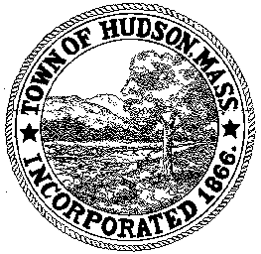

BOARD OF HEALTH
78 Main Street
Hudson, MA 01749
(978) 562-2020
Meeting Agenda
March 20, 2012
7:00 PM

- Preliminaries
1.1 Open Meeting
1.2 Roll Call

2.0 General Business
2.1 Central MA Mosquito Control Project

2.2 Metrowest Health Foundation Grant Application

2.3 Cumberland Farms Variance Request

2.4 Tobacco Control

2.5 Voucher BOH 030612 $1,931.40
Voucher BOH 032012 $600

2.6 Minutes March 6, 2012

3.0 Site Plan Reviews
3.1 350 Main Street
3.2 141/153 Broad Street

4.0 Correspondence

5.0 Adjournment

Next Meeting April 10, 2012

